What am I feeling?
defining emotions
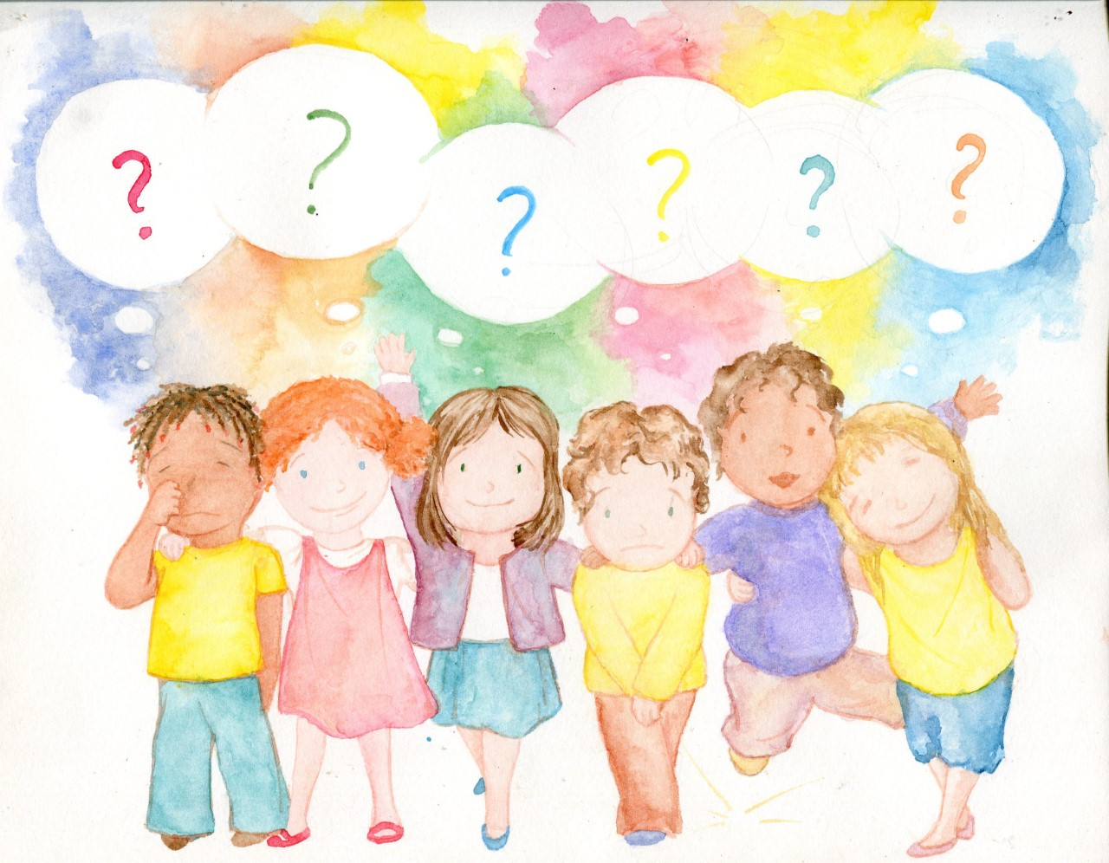

By Katie Flanagan
Illustrated by Anna Krupa

